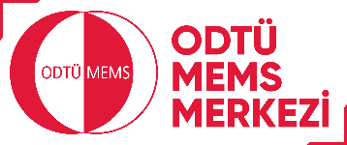 | METU MEMS CENTER  DICING REQUEST FORM

Date :

PERSONAL INFORMATION

Contact Person / Title

Organization Name

E-mail

Phone

Project Code-Title/ Thesis Title

SAMPLE INFORMATION
Substrate type
Substrate size
Substrate thickness
(including all added up layers)
Number of samples
Ident N^{os} (optional)
Request will not be processed unless the information required above is given in full

Comments:
Please include the following information as much as possible: Schematic drawing of the sample and cut-lines (please indicate full-depth cuts with thick lines and half-depth cuts with thin lines), center to center spacing of dicing lines, the depth in microns to be left after half-depth cuts, information about alignment and cut-line spacing to structures with a drawing. Please prepare the information for every different sample cutting.

ODTÜ MEMS MERKEZİ
Kesim İstek Formu
(Örnek)

TARİH :

KİŞİYE AİT BİLGİLER
İlgili kişi / unvan | Ali Veli
Kurum / Kuruluş Adı | …Üniversitesi, Mak. Müh. Böl.

E-posta

Telefon:
Proje Kodu-İsmi / Tez Başlığı | TUBİTAK XXXX Kodlu xxxxxx projesi

ÖRNEK BİLGİSİ
Taban malzeme tipi | Cama yapıştırılmış silisyum.
Taban malzeme büyüklüğü | 100 mm
Taban malzeme kalınlığı  (bütün ilave tabakalar dahil) | 500µm cam+ 100µm silisyum + 10µ fotorezist
Örnek sayısı | 1
Sıra No: (isteğe bağlı) | Xx

Yukarıda talep edilen bilgiler eksiksiz verilmediği takdirde talep işleme alınmayacaktır

Ek Bilgi:

